**How to Upgrade Temperature Screening Terminal**

**Steps**

1. **Upgrade main firmware.**

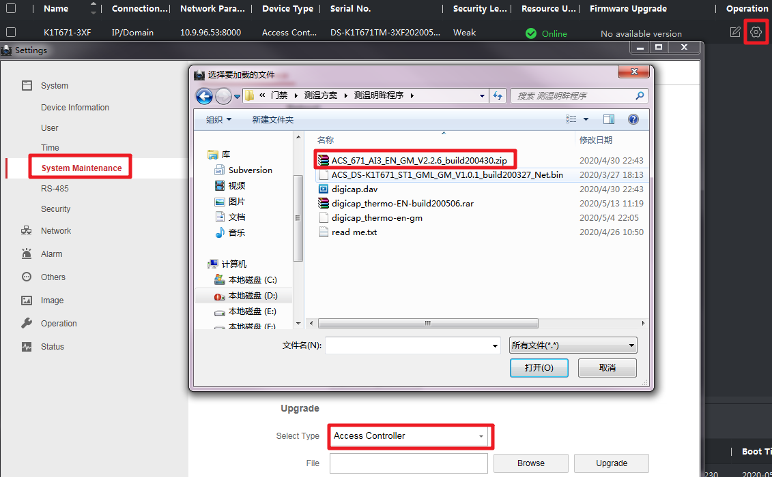

1. **Upgrade extension firmware.**

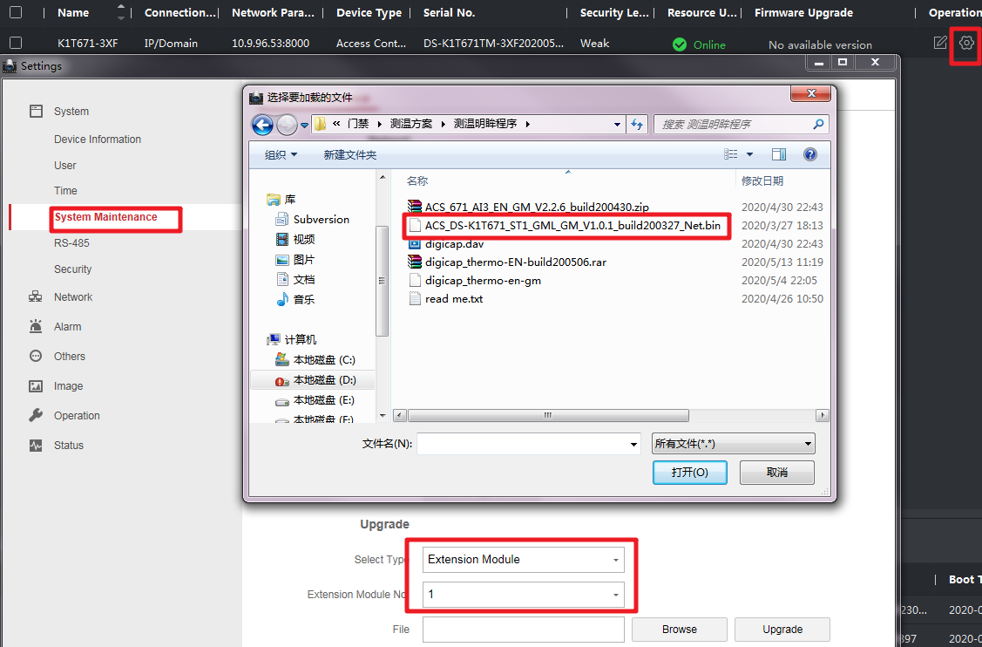

1. **Upgrade thermal module firmware.**

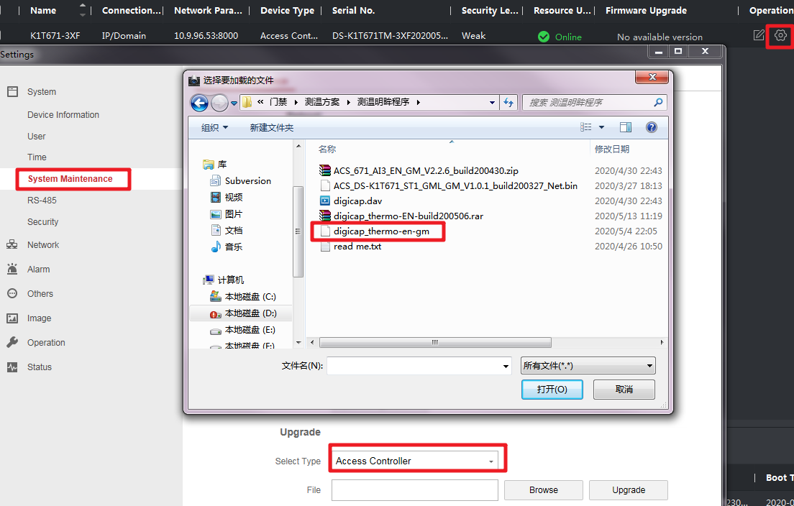

**See Far, Go Further**

***HIK*VISION Technical Support**